LKS INDUSTRIES
Industrial Valves · Strainers · Vessels · Structural Fabrication

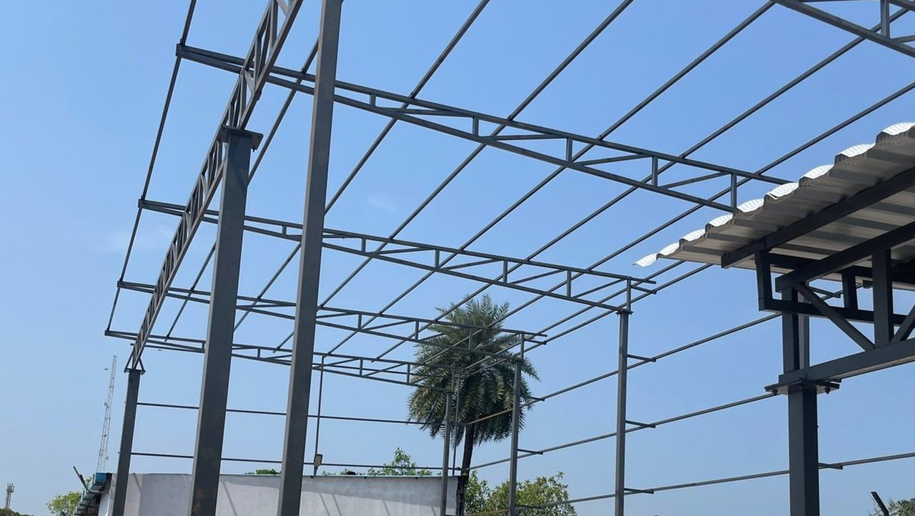
Capability Catalogue · 2026
STRUCTURAL FABRICATION
& ERECTION
Pre-engineered buildings, industrial sheds, structural steel frames, pipe racks, mezzanine floors, platforms and site infrastructure — designed, fabricated in-house and erected at site across Tamil Nadu and South India.

Ajay T  Business Development Executive | sales.lksindustries@gmail.com  +91 93846 88319 · Chennai, Tamil Nadu
ISO 9001 Certified · MSME Registered · GST Registered
01 · WHO WE ARE

An in-house fabricator, not a trader.

LKS Industries manufactures industrial valves, strainers, storage tanks, pressure vessels, heat exchangers, pipe spools and skids from its own facility in Chennai. The same shop floor, welding capability and site crew support our structural division — so the steel that frames your plant and the equipment that runs inside it come from one accountable vendor.
Structural scope of works
Capability | Typical scope
Pre-Engineered Buildings & Sheds | Portal frames, lattice trusses, built-up columns, purlin grids, roof and wall sheeting for production bays, warehouses and utility blocks.
Structural Frames & Canopies | Tubular and built-up frames for covered yards, loading canopies, entrance porches, equipment shelters and machinery enclosures.
Pipe Racks, Trestles & Supports | Lattice and box trestle lines, cantilever brackets and sleeper supports for overhead piping, cable trays and service runs.
Mezzanine Floors & Platforms | Steel floor beams and joist grids with chequered plate, grating or RCC deck; elevated operating and maintenance platforms.
Stairs, Ladders, Handrails & Walkways | Staircases with treads and stringers, cage ladders, walkway grating and handrail systems to plant safety requirements.
Gates, Enclosures & Site Infrastructure | Heavy MS gates, security cabins, compound framing, storage racks, bunds and miscellaneous site steelwork.
Materials & workmanship
Structural | MS sections to IS 2062 grade — ISMB, ISMC, ISA, RHS / SHS, plate and built-up members.
Stainless | SS 304, SS 316 and SS 316L frames, platforms and supports for corrosive or hygienic areas.
Finish | Surface preparation, red-oxide or zinc primer, epoxy / PU top coat, or galvanising as specified.
Inspection | Fit-up, weld and dimensional checks; client and consultant inspection welcome at our shop.
Sectors served
Oil & Gas | Petrochemicals | EPC & Projects | Chemical Manufacturing
Water Treatment | Pharma | Food & Beverage | General Engineering
Certifications held: ISO 9001 Quality Management · MSME Registered · GST Registered
Third-party inspection (TPI) can be arranged for pressure equipment. Structural fabrication is carried out to IS dimensional standards and to approved client drawings.
02 · PROJECT GALLERY

Pre-Engineered Buildings & Industrial Sheds

Portal and lattice framing for production bays, utility blocks and covered storage — shop-fabricated in numbered sub-assemblies and bolted up at site.
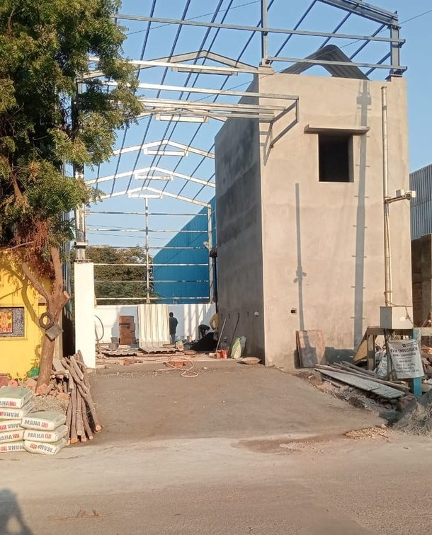  Shed Framing — Erection in Progress  Portal columns and rafters with a tubular purlin grid going up alongside the RCC utility block. Members arrive shop-primed and match-marked for a bolted site fit-up.  Portal frame · Tubular purlins · Site erection |  | 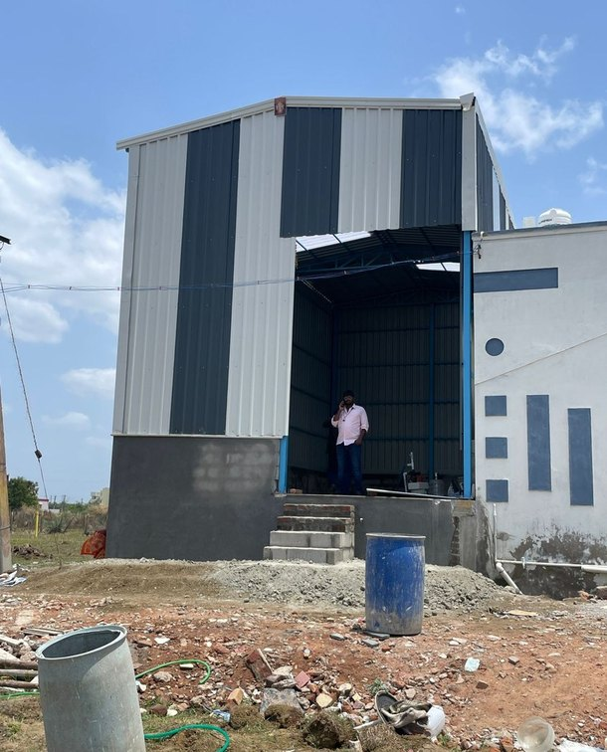  Vertical Bay Extension, Clad & Closed  A tall single-bay structure tied into an existing plant building, finished in colour-coated profile sheeting to walls and roof, with a clear-span working opening at grade.  Brownfield tie-in · Profile sheeting · Clear span
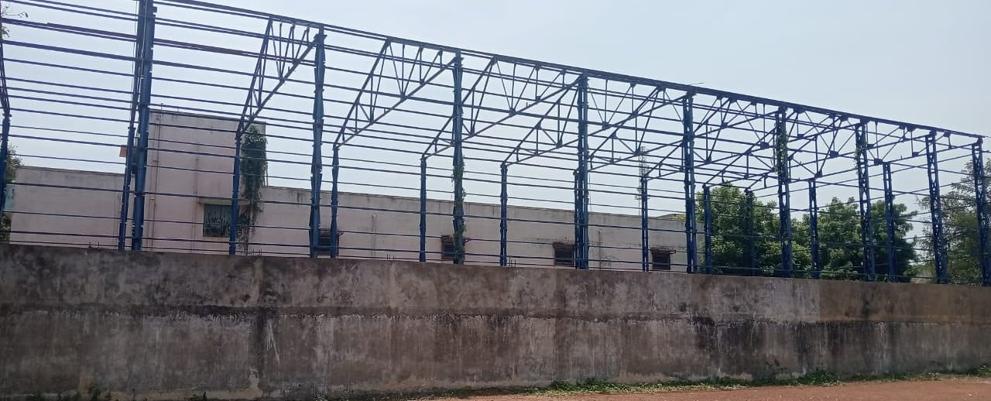
Long-Span Production Bay — Lattice Truss Framework
Multi-bay lattice trusses seated on built-up lattice columns, spanning a full production floor. Painted and inspected before sheeting, so no coating work is left at height.
Lattice truss · Multi-bay · Long span · Shop-painted
03 · PROJECT GALLERY

Structural Frames, Canopies & Pipe Racks

Open frames and trestle lines that carry loads other than roofs — services, material handling and weather protection across the plant yard.
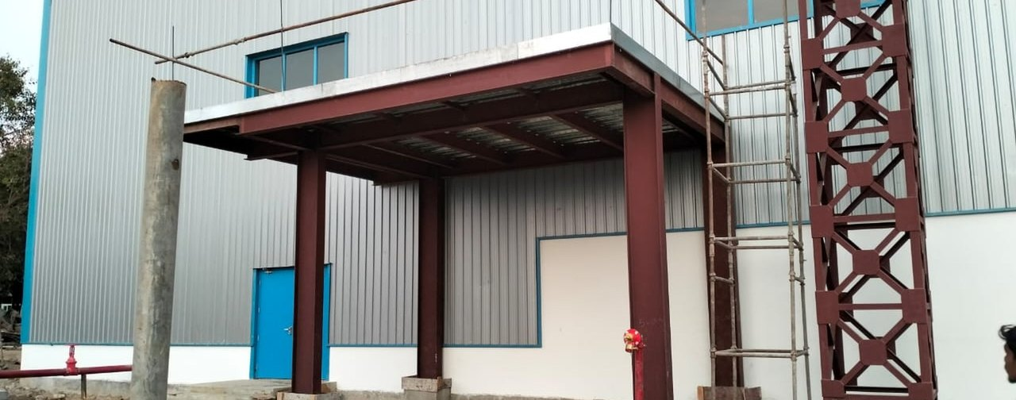
Plant Building with Structural Entrance Canopy
Completed clad building with a beam-and-column canopy over the entry bay, plus an adjacent lattice tower structure. Canopy steel is set out to clear vehicle movement beneath.
Canopy frame · Lattice tower · Clad building
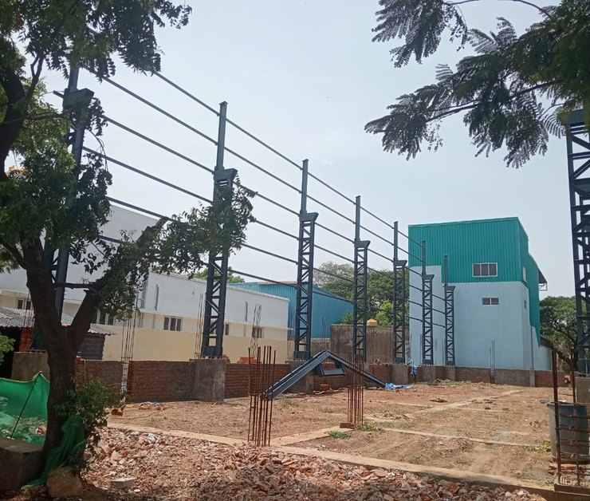  Trestle Line for Overhead Services  A run of lattice trestle columns with cantilever head brackets carrying overhead service lines across a working yard — erected between live buildings with minimal ground obstruction.  Lattice trestle · Cantilever brackets · In-plant run |  | 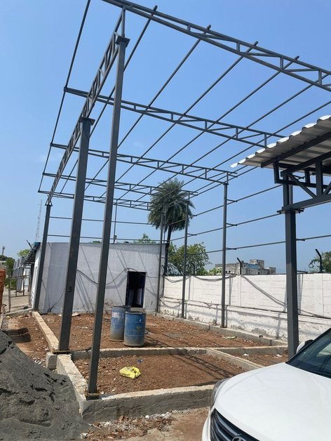  Covered Yard Frame  Tubular columns with truss rafters and a purlin grid for a covered handling area; roof sheeting in progress.  Tubular columns · Truss rafters
04 · PROJECT GALLERY

Mezzanines, Platforms & Site Infrastructure

Elevated floors and access steel that add usable area inside an existing footprint — plus the secondary fabrication a site needs to run.
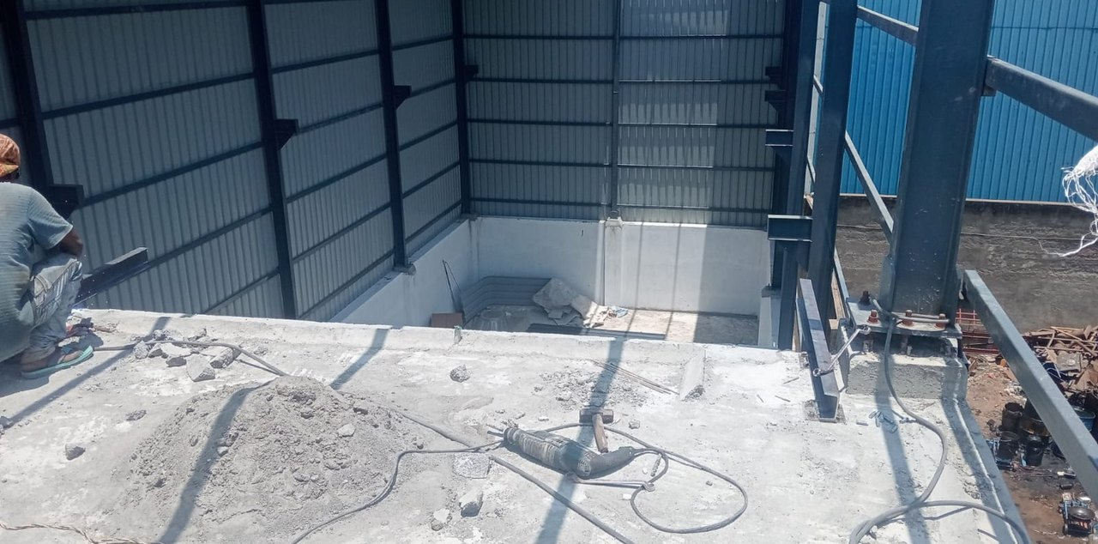
Elevated Mezzanine Floor within a Fabricated Bay
Structural floor beams tied into the main columns and decked to take load, with side sheeting closed off around it. Built inside a working bay to add floor area without extending the plot.
Mezzanine deck · Column tie-in · Load-rated
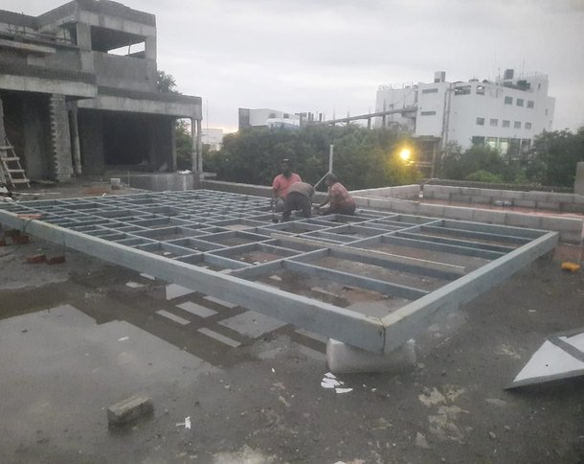  Roof-Level Platform Grid  Hollow-section grid assembled at roof level for an equipment deck — shop-cut and welded up in position where crane access is restricted.  RHS grid · Equipment deck |  | 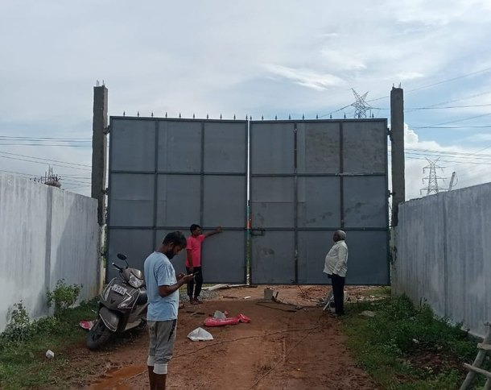  Heavy MS Main Gate & Compound Steel  Double-leaf framed gate with sheet infill and spear-top rail, installed on RCC posts as part of the site boundary package.  MS framed leaf · Site install
05 · WORKING WITH US

From drawing to erected steel.

We quote on your GA drawing or work from a site visit, and prepare fabrication drawings for approval before cutting steel.
01 | Enquiry & site data | Drawings, spans, heights, loads and site constraints reviewed.
02 | Quotation | Rate per MT or lump sum, with scope, finish and exclusions written out.
03 | Fabrication drawings | Shop drawings issued for your approval before material is cut.
04 | Shop fabrication | Cutting, fit-up, welding and painting under in-house supervision.
05 | Delivery & erection | Transport, site erection, alignment and handover with records.
What we need to quote accurately
- GA drawing or sketch — bay spacing, span and eave height
- Crane / hoist details, if the structure is to carry one
- Roof and wall sheeting specification, or sheeting by others
- Floor loading for mezzanines and platforms (kg/m²)
- Paint system required — primer only, epoxy, PU or galvanised
- Site location, access and target erection window
Also manufactured in-house
Valves | Gate, Globe, Ball, Butterfly, Needle, Knife Gate, Check / NRV, Foot, Safety Relief and Pressure Reducing Valves.
Strainers | Y-Strainers ½" to 60", Basket Strainers (Simplex & Duplex), T-Strainers and Conical Strainers.
Equipment | Storage tanks, pressure vessels, heat exchangers, pipe spools and skids — TPI available for pressure equipment.
Materials | Carbon Steel, SS 304, SS 316, SS 316L, Cast Iron and Ductile Iron.
Send us your drawing  Ajay T  Business Development Executive  LKS Industries, Chennai | sales.lksindustries@gmail.com  +91 93846 88319  Chennai, Tamil Nadu, India

